MongoDB server Advanced 10

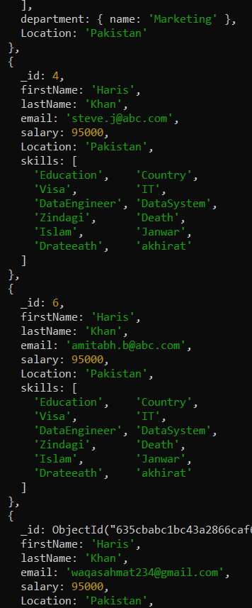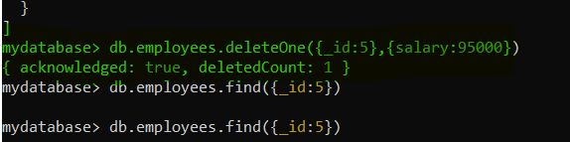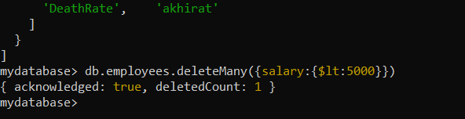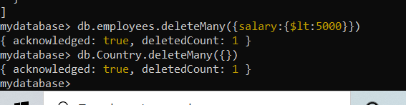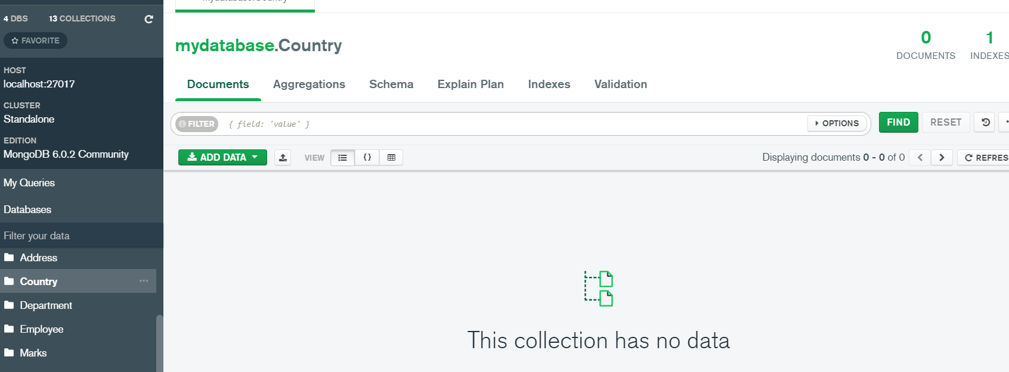

**Coding part:**

mydatabase> db.employees.deleteMany({salary:{$lt:5000}})

{ acknowledged: true, deletedCount: 1 }

mydatabase> db.Country.deleteMany({})

{ acknowledged: true, deletedCount: 1 }

... _id: 101,

... street:"Upper Street",

... house:"No 1",

... city:"New York",

... country:"USA"

... })

{ acknowledged: true, insertedId: 101 }

mydatabase>

mydatabase> db.employee.insertOne({

... firstName: "John",

... lastName: "King",

... email: "john.king@abc.com",

... salary: "33000",

... DoB: new Date('Mar 24, 2011'),

... address: 101

mydatabase> db.employee.find({firstName:"John"})

[

{cknowledged: true,

_id: ObjectId("635df1540ac0ff7a169fad25"),25")

firstName: 'John',

lastName: 'King',

email: 'john.king@abc.com',

salary: '33000',

DoB: ISODate("2011-03-23T19:00:00.000Z"),

address: 101

}

]

mydatabase> db.address.find({_id:101})

[

{

_id: 101,

street: 'Upper Street',

house: 'No 1',

city: 'New York',

country: 'USA'

}

]

mydatabase> db.employee.insertOne({ firstName: "khan", lastName: "King", email: "khan.king@abc.com", salary: "33000", DoB: new Date('Mar 24, 2011'), address: 101 })

{

acknowledged: true,

insertedId: ObjectId("635df2280ac0ff7a169fad26")

}

mydatabase> db.employee.insertOne({ firstName: "bannu", lastName: "King", email: "bannu.king@abc.com", salary: "33000", DoB: new Date('Mar 14, 2011'), address: 101 })

{

acknowledged: true,

insertedId: ObjectId("635df24c0ac0ff7a169fad27")

}

mydatabase> db.address.insertOne({ _id: 102, street: "Upper Street", house: "No 1", city: "New York", country: "USA" })

{ acknowledged: true, insertedId: 102 }

mydatabase> db.address.insertOne({ _id: 103, street: "Upper Street", house: "No 1", city: "New York", country: "USA" })

{ acknowledged: true, insertedId: 103 }

mydatabase> db.address.insertOne({ _id: 104, street: "Upper Street", house: "No 1", city: "New York", country: "USA" })

{ acknowledged: true, insertedId: 104 }

mydatabase> var addrid=db.employee.findOne({firstName:"John"}).address;

mydatabase> db.address.findOne({_id:addrid})

{

_id: 101,

street: 'Upper Street',

house: 'No 1',

city: 'New York',

country: 'USA'

}

mydatabase> db.employee.aggregate([{$lookup:{from:'address',localField:'address',foreignField:'_id',as:'addrid'}}])

[

{

_id: ObjectId("635df1540ac0ff7a169fad25"),

firstName: 'John',

lastName: 'King',

email: 'john.king@abc.com',

salary: '33000',

DoB: ISODate("2011-03-23T19:00:00.000Z"),

address: 101,

addrid: [

{

_id: 101,

street: 'Upper Street',

house: 'No 1',

city: 'New York',

country: 'USA'

}

]

},

{

_id: ObjectId("635df2280ac0ff7a169fad26"),

firstName: 'khan',

lastName: 'King',

email: 'khan.king@abc.com',

salary: '33000',

DoB: ISODate("2011-03-23T19:00:00.000Z"),

address: 101,

addrid: [

{

_id: 101,

street: 'Upper Street',

house: 'No 1',

city: 'New York',

country: 'USA'

}

]

},

{

_id: ObjectId("635df24c0ac0ff7a169fad27"),

firstName: 'bannu',

lastName: 'King',

email: 'bannu.king@abc.com',

salary: '33000',

DoB: ISODate("2011-03-13T19:00:00.000Z"),

address: 101,

addrid: [

{

_id: 101,

street: 'Upper Street',

house: 'No 1',

city: 'New York',

country: 'USA'

}

]

}

]

mydatabase>

**Task23 End**

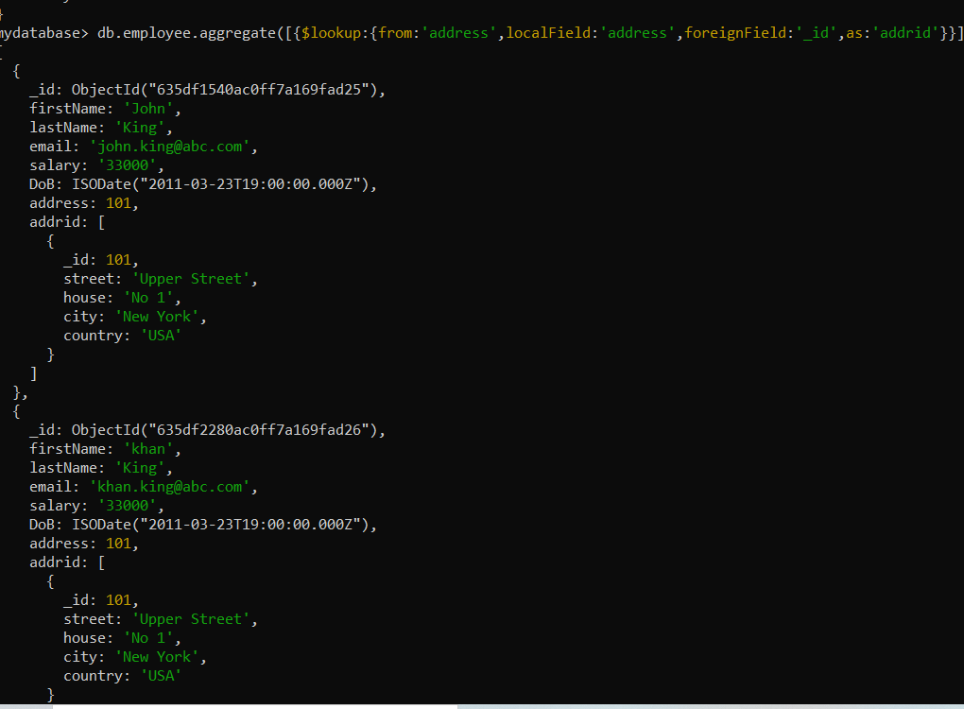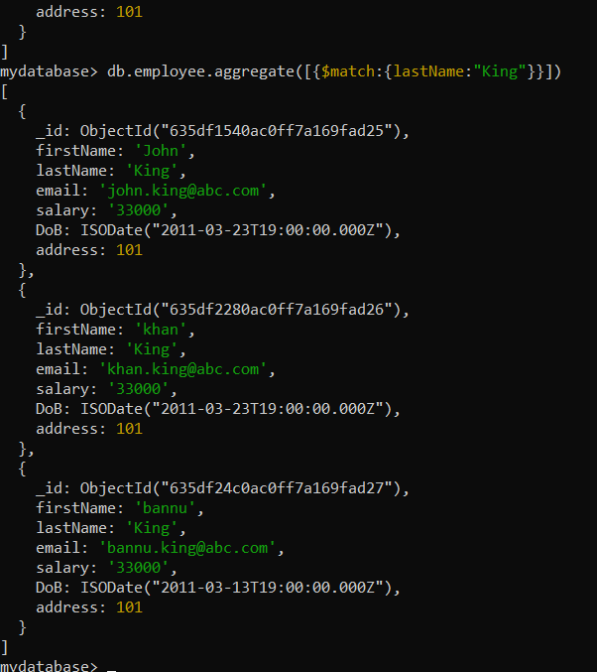

**Coding part2 :**

mydatabase> db.employee.find().pretty()

[

{

_id: ObjectId("635df1540ac0ff7a169fad25"),

firstName: 'John',

lastName: 'King',

email: 'john.king@abc.com',

salary: '33000',

DoB: ISODate("2011-03-23T19:00:00.000Z"),

address: 101

},

{

_id: ObjectId("635df2280ac0ff7a169fad26"),

firstName: 'khan',

lastName: 'King',

email: 'khan.king@abc.com',

salary: '33000',

DoB: ISODate("2011-03-23T19:00:00.000Z"),

address: 101

},

{

_id: ObjectId("635df24c0ac0ff7a169fad27"),

firstName: 'bannu',

lastName: 'King',

email: 'bannu.king@abc.com',

salary: '33000',

DoB: ISODate("2011-03-13T19:00:00.000Z"),

address: 101

}

]

mydatabase> db.employee.aggregate([{$match:{lastName:"King"}}])

[

{

_id: ObjectId("635df1540ac0ff7a169fad25"),

firstName: 'John',

lastName: 'King',

email: 'john.king@abc.com',

salary: '33000',

DoB: ISODate("2011-03-23T19:00:00.000Z"),

address: 101

},

{

_id: ObjectId("635df2280ac0ff7a169fad26"),

firstName: 'khan',

lastName: 'King',

email: 'khan.king@abc.com',

salary: '33000',

DoB: ISODate("2011-03-23T19:00:00.000Z"),

address: 101

},

{

_id: ObjectId("635df24c0ac0ff7a169fad27"),

firstName: 'bannu',

lastName: 'King',

email: 'bannu.king@abc.com',

salary: '33000',

DoB: ISODate("2011-03-13T19:00:00.000Z"),

address: 101

}

]

mydatabase> db.employees.aggregate([{$group:{_id:"skills"}}])

[ { _id: 'skills' } ]

mydatabase> db.employees.aggregate([{$group:{_id:'$department.name'}}])

[

{ _id: 'Finance' },

{ _id: 'IT' },

{ _id: 'Marketing' },

{ _id: null }

]

mydatabase> db.employees.aggregate([{$group:{_id:'$department.name',totalEmployees:{$sum:1}}}])

[

{ _id: 'Marketing', totalEmployees: 2 },

{ _id: null, totalEmployees: 10 },

{ _id: 'Finance', totalEmployees: 3 },

{ _id: 'IT', totalEmployees: 3 }

]

mydatabase> db.employees.aggregate([{$match:{lastName:"King"}},{$group:{_id:'$department.name',totalEmployees:{$sum:1}}}])

[ { _id: null, totalEmployees: 1 } ]

mydatabase> db.employees.aggregate([{$match:{gender:"male"}},{$group:{_id:'$department.name',totalEmployees:{$sum:1}}}])

mydatabase> db.enployees.updateMany({},{$set:{gender:"Male"}})

{

acknowledged: true,

insertedId: null,

matchedCount: 0,

modifiedCount: 0,

upsertedCount: 0

}

mydatabase> db.enployees.updateMany({_id:1},{$set:{gender:"Male"}})

{

acknowledged: true,

insertedId: null,

matchedCount: 0,

modifiedCount: 0,

upsertedCount: 0

}

mydatabase> db.enployees.updateMany({firstName:"Haris"},{$set:{gender:'Male'}})

{

acknowledged: true,

insertedId: null,

matchedCount: 0,

modifiedCount: 0,

upsertedCount: 0

}

mydatabase> db.employees.aggregate([{$match:{gender:"male"}},{$group:{_id:'$department.name',totalEmployees:{$sum:'$salary'}}}])

mydatabase> db.employees.aggregate([{$match:{gender:"Male"}},{$group:{_id:'$department.name',totalEmployees:{$sum:'$salary'}}}])

[

{ _id: 'IT', totalEmployees: 95000 },

{ _id: null, totalEmployees: 95000 },

{ _id: 'Finance', totalEmployees: 95000 },

{ _id: 'Marketing', totalEmployees: 95000 }

]

mydatabase> db.employees.aggregate([{$match:{gender:"Male"}},{$group:{_id:'$department.name',totalSalaraies:{$sum:'$salary'}}}])

[

{ _id: 'IT', totalSalaraies: 95000 },

{ _id: null, totalSalaraies: 95000 },

{ _id: 'Marketing', totalSalaraies: 95000 },

{ _id: 'Finance', totalSalaraies: 95000 }

]

mydatabase> db.employees.aggregate([{$match:{gender:"Female"}},{$group:{_id:'$department.name',totalSalaraies:{$sum:'$salary'}}}])

[ { _id: null, totalSalaraies: 190000 } ]

mydatabase> db.employees.aggregate([{$match:{gender:"Female"}},{$group:{_id:'$department.name',totalSalaraies:{$avg:'$salary'}}}])

[ { _id: null, totalSalaraies: 95000 } ]

mydatabase> db.employees.aggregate([{$match:{gender:"Female"}},{$group:{_id:'$department.name',averageSalaray:{$avg:'$salary'}}}])

[ { _id: null, averageSalaray: 95000 } ]

mydatabase> db.employees.aggregate([{$match:{gender:"Male"}},{$group:{_id:'$department.name',averageSalaray:{$avg:'$salary'}}}])

[

{ _id: 'IT', averageSalaray: 95000 },

{ _id: null, averageSalaray: 95000 },

{ _id: 'Finance', averageSalaray: 95000 },

{ _id: 'Marketing', averageSalaray: 95000 }

]

mydatabase> db.employees.aggregate([{$match:{gender:"Male"}},{$sort:{firstName:1}}])

[

{

_id: 1,

firstName: 'Haris',

lastName: 'Khan',

email: 'jamilking345@gmail.com',

salary: 95000,

skills: [

'React', 'MongoDB',

'Sports', 'Education',

'Country', 'Visa',

'IT', 'DataEngineer',

'DataSystem', 'Zindagi',

'Death', 'Islam',

'Janwar', 'Drateeath',

'akhirat'

],

department: { name: 'IT' },

Location: 'Pakistan',

gender: 'Male'

},

{

_id: 2,

firstName: 'Haris',

lastName: 'Khan',

email: 'sachin.t@abc.com',

salary: 95000,

skills: [

'Tax', 'Sports',

'Education', 'Country',

'Visa', 'IT',

'DataEngineer', 'DataSystem',

'Zindagi', 'Death',

'Islam', 'Janwar',

'Drateeath', 'akhirat'

],

department: { name: 'Finance' },

Location: 'Pakistan',

gender: 'Male'

},

{

_id: 3,

firstName: 'Haris',

lastName: 'Khan',

email: 'jamesb@abc.com',

salary: 95000,

skills: [

'Marketing', 'Sports',

'Education', 'Country',

'Visa', 'IT',

'DataEngineer', 'DataSystem',

'Zindagi', 'Death',

'Islam', 'Janwar',

'Drateeath', 'akhirat'

],

department: { name: 'Marketing' },

Location: 'Pakistan',

gender: 'Male'

},

{

_id: 4,

firstName: 'Haris',

lastName: 'Khan',

email: 'steve.j@abc.com',

salary: 95000,

Location: 'Pakistan',

skills: [

'Education', 'Country',

'Visa', 'IT',

'DataEngineer', 'DataSystem',

'Zindagi', 'Death',

'Islam', 'Janwar',

'Drateeath', 'akhirat'

],

gender: 'Male'

}

]

mydatabase> db.employees.aggregate([{$match:{gender:"Male"}},{$group:{_id:'$department.name',TotalEmployees:{$sum:1}}},{$sort:{firstName:1}}])

[

{ _id: 'Finance', TotalEmployees: 1 },

{ _id: 'IT', TotalEmployees: 1 },

{ _id: 'Marketing', TotalEmployees: 1 },

{ _id: null, TotalEmployees: 1 }

]

mydatabase>

